**DEVELOPMENT of custom connector (windows):**

**Requirement:** Visual Studio Code,Power Query SDK (extension)

**Download** Visual Studio Code.

Open extensions (ctrl+shift+X). Install Power Query SDK

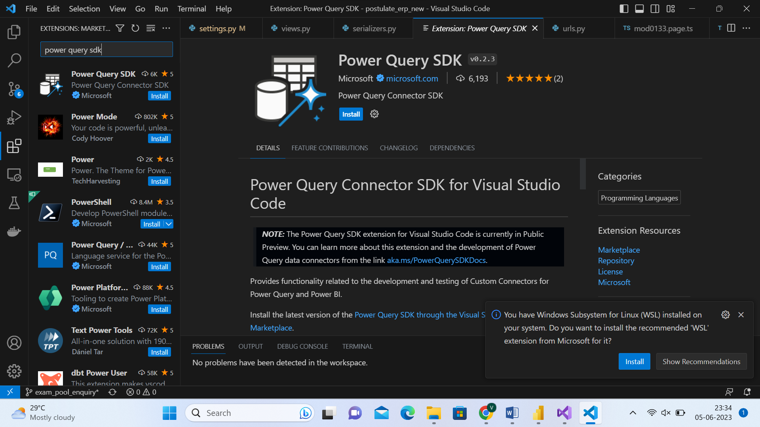

**After installing the extension, power query sdk bar appears in explorer view**

Refer <https://learn.microsoft.com/en-us/power-query/power-query-sdk-vs-code>

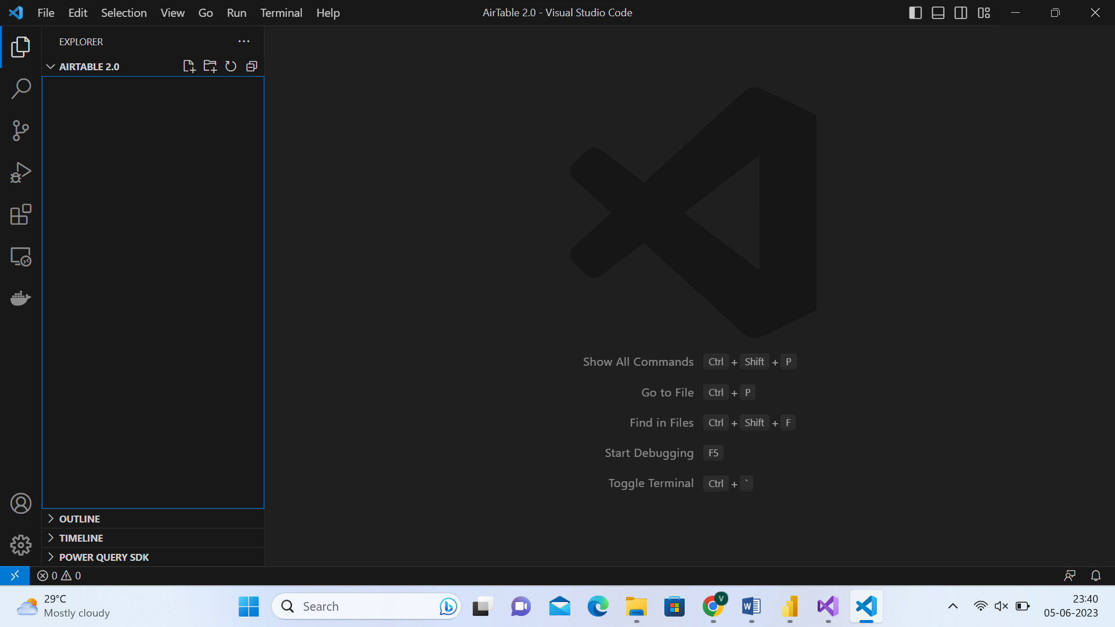

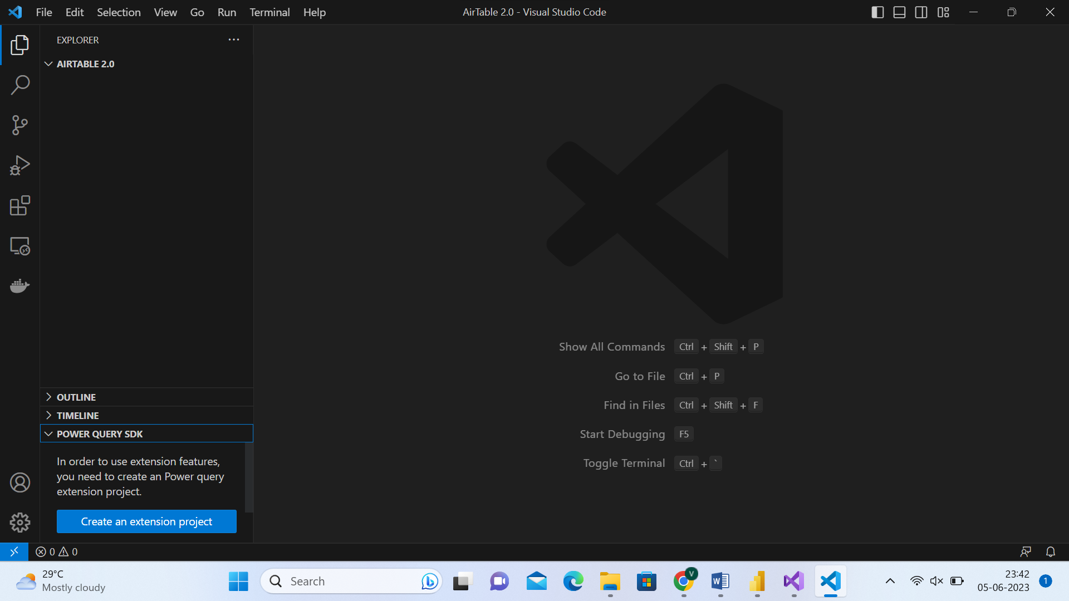

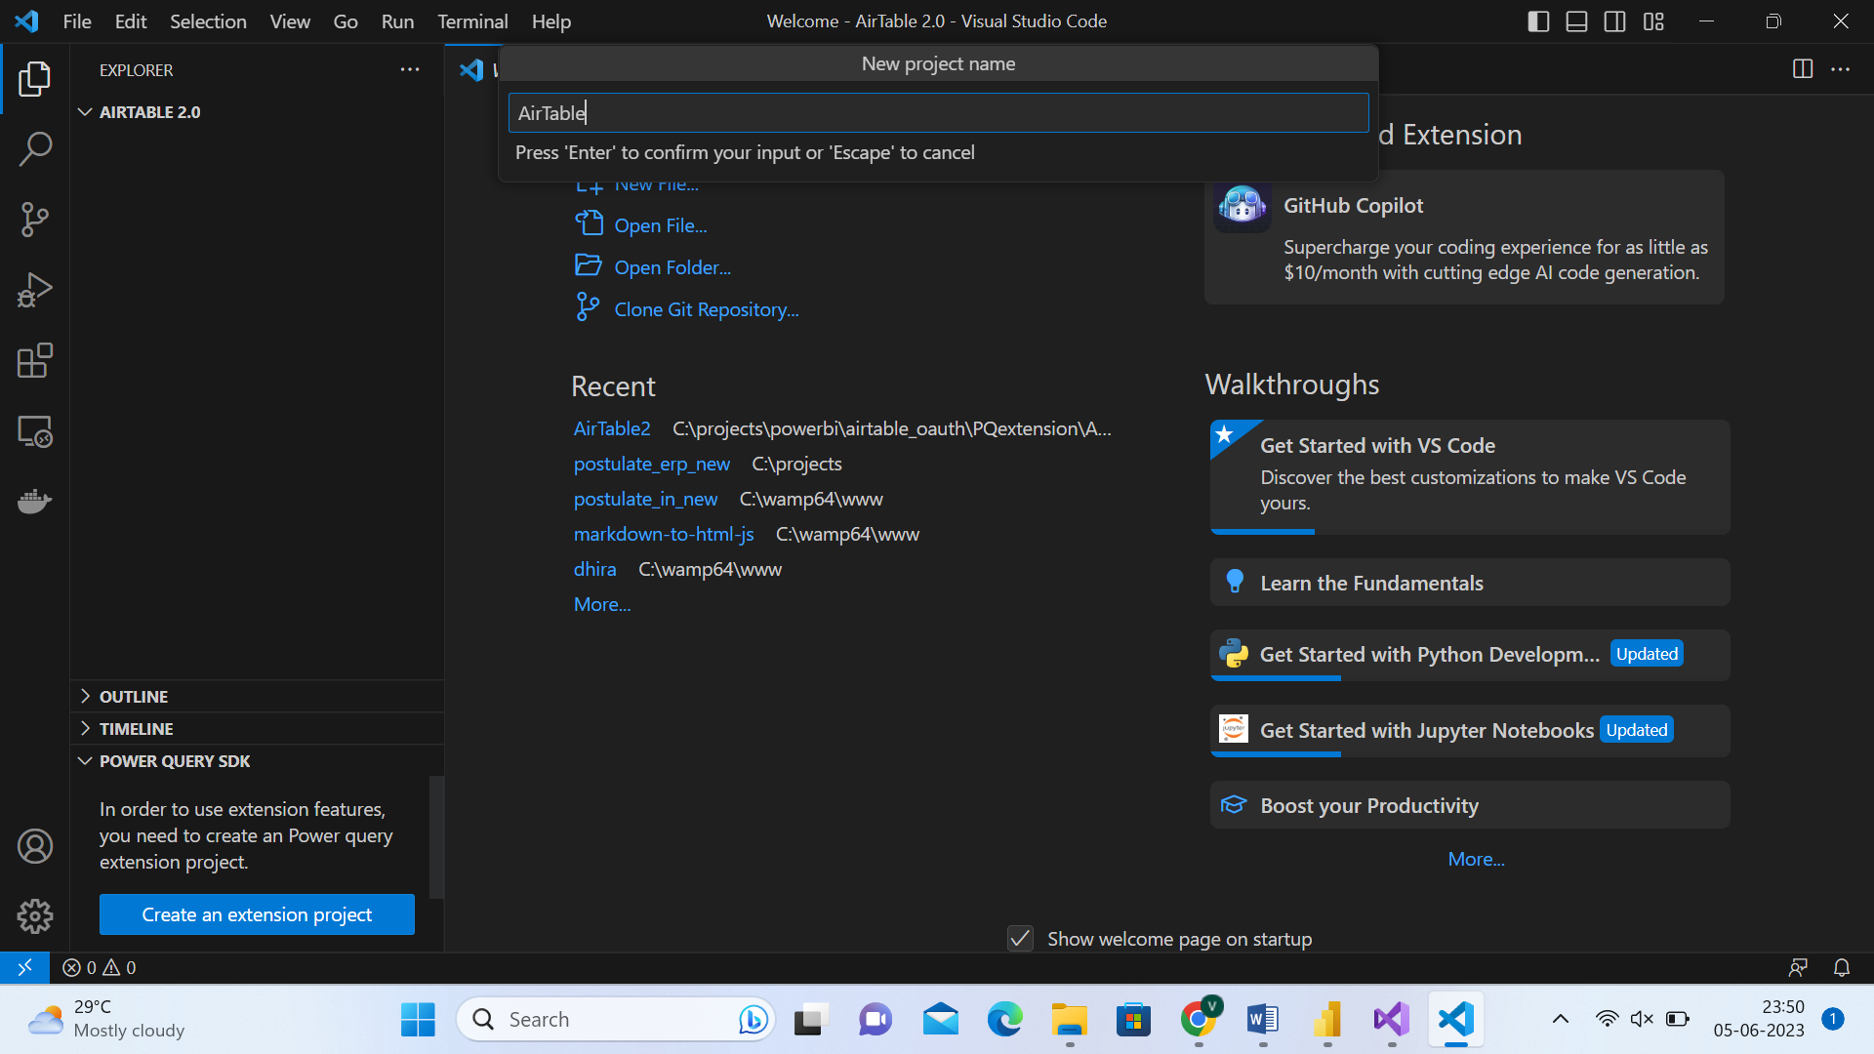

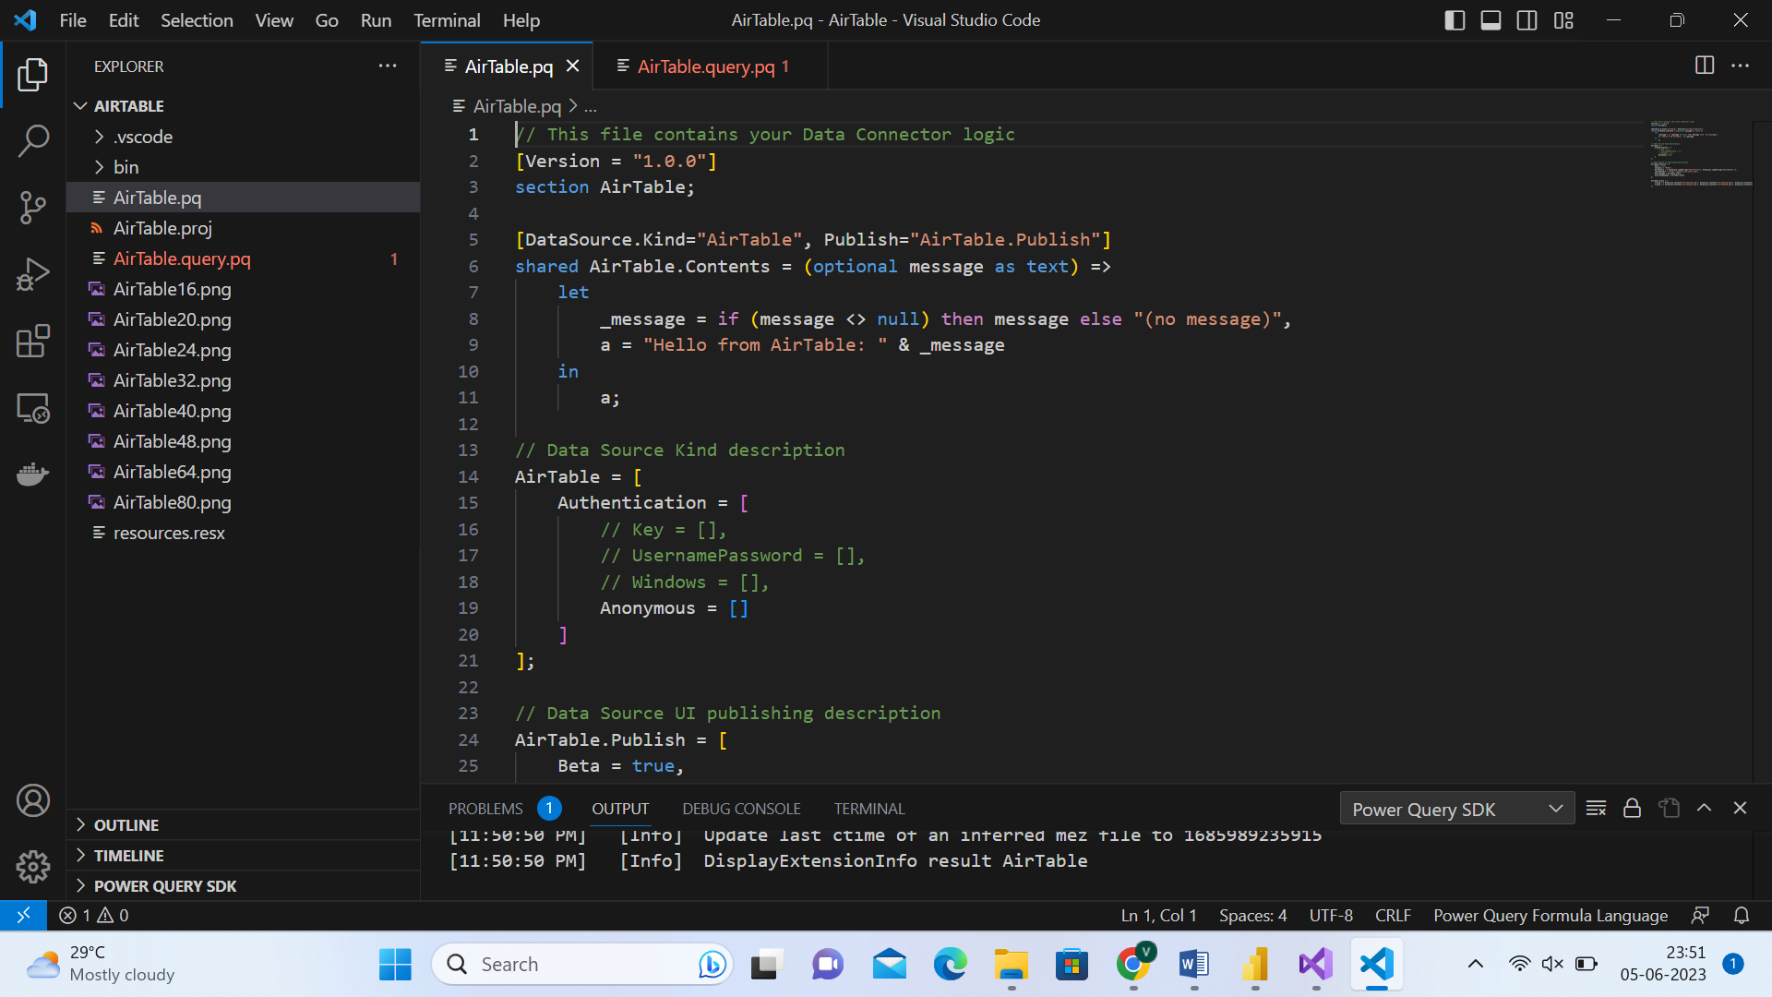

**Update .pq file to the following contents:**

// This file contains your Data Connector logic

[Version = "1.0.0"]

section AirTable;

PAT = "ENTER_PERSONAL_ACCESS_TOKEN_HERE";

[DataSource.Kind="AirTable", Publish="AirTable.Publish"]

shared AirTable.Contents = (BASE_ID as text, TABLE_ID as text, VIEW_ID as text) =>

    let Pagination

        = List.Skip( List.Generate( () => [Page_Key = "init", Counter=0], // Start Value

            each [Page_Key] <> null, // Condition under which the next execution will happen

            each [

                Page_Key = try if [Counter]<1 then ""

                    else

                        [WebCall][Value][offset] otherwise null, // determine the LastKey for the next execution

                WebCall = try if [Counter]<1

                    then

                        Json.Document(Web.Contents("https://api.airtable.com",[RelativePath="v0/"&BASE_ID&"/"&TABLE_ID,Headers=[Authorization="Bearer "&PAT]]))

                    else

                        Json.Document(Web.Contents("https://api.airtable.com",[RelativePath="v0/"&BASE_ID&"/"&TABLE_ID&"?offset="&[WebCall][Value][offset], Headers=[Authorization="Bearer "&PAT]])),// retrieve results per call

                Counter = [Counter]+1// internal counter

            ],

            each [WebCall]

        ),1)

in

    Pagination;

// Data Source Kind description

AirTable = [

    TestConnection = (dataSourcePath) =>

        let

            json = Json.Document(dataSourcePath), BASE_ID = json[BASE_ID], TABLE_ID = json[TABLE_ID], VIEW_ID = json[VIEW_ID]

        in

            { "AirTable.Contents", BASE_ID, TABLE_ID, VIEW_ID },

    Authentication = [

        // Key = [],

        // UsernamePassword = [],

        // Windows = [],

        Anonymous = []

    ]

];

// Data Source UI publishing description

AirTable.Publish = [

    Beta = true,

    Category = "Other",

    ButtonText = { Extension.LoadString("ButtonTitle"), Extension.LoadString("ButtonHelp") },

    LearnMoreUrl = "https://powerbi.microsoft.com/",

    SourceImage = AirTable.Icons,

    SourceTypeImage = AirTable.Icons

];

AirTable.Icons = [

    Icon16 = { Extension.Contents("AirTable16.png"), Extension.Contents("AirTable20.png"), Extension.Contents("AirTable24.png"), Extension.Contents("AirTable32.png") },

    Icon32 = { Extension.Contents("AirTable32.png"), Extension.Contents("AirTable40.png"), Extension.Contents("AirTable48.png"), Extension.Contents("AirTable64.png") }

];

**EVALUATE CURRENT POWER QUERY FILE**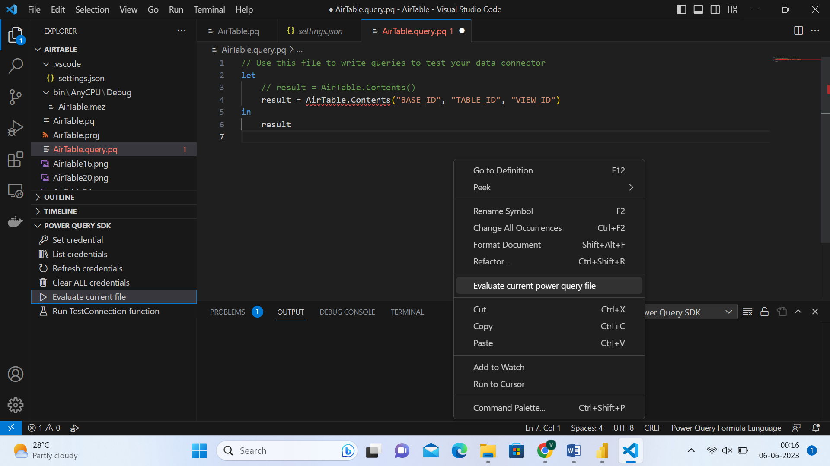

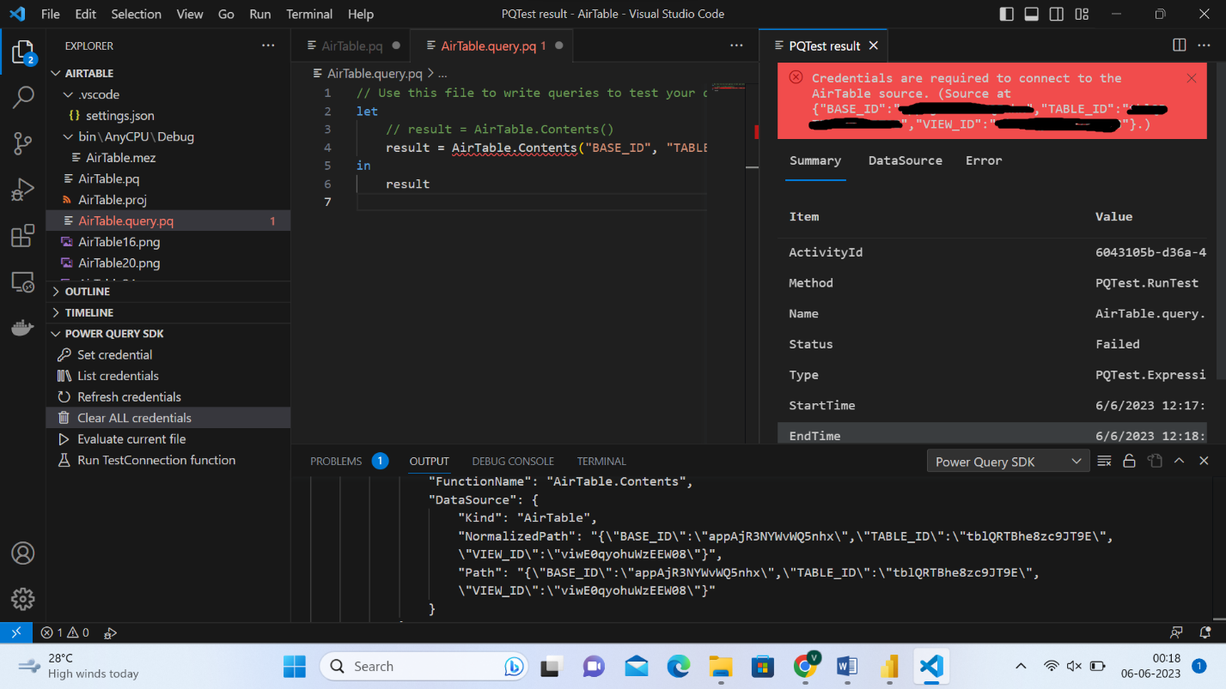

**SET CREDENTIAL**

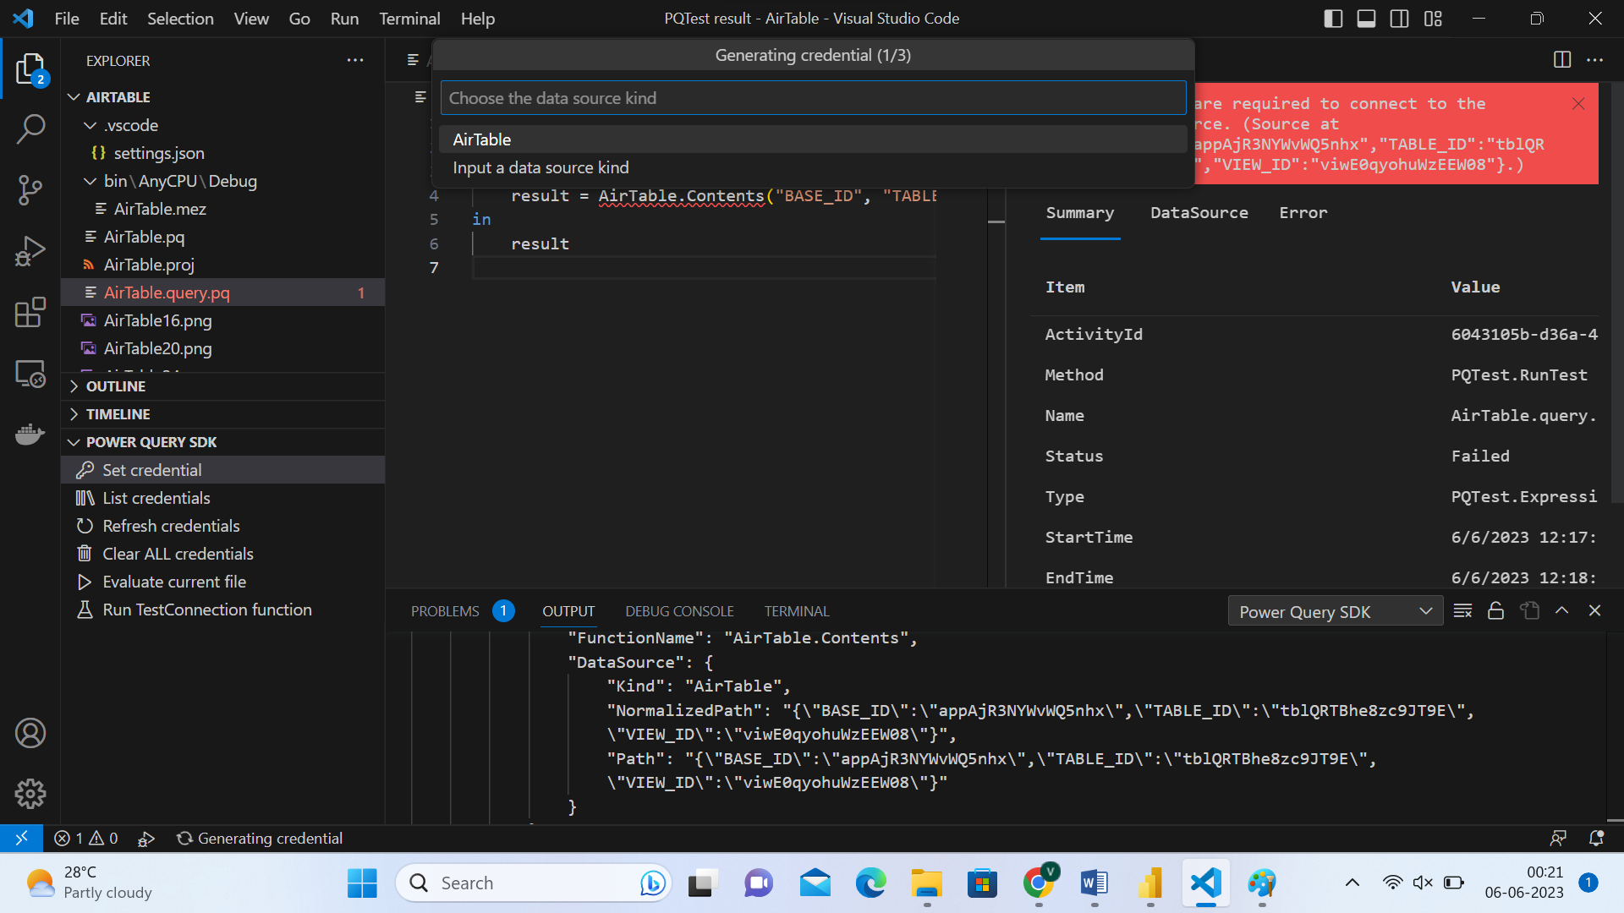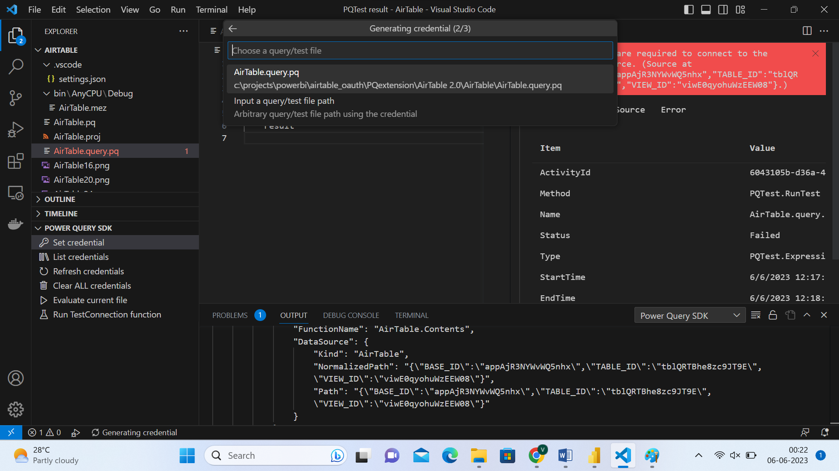

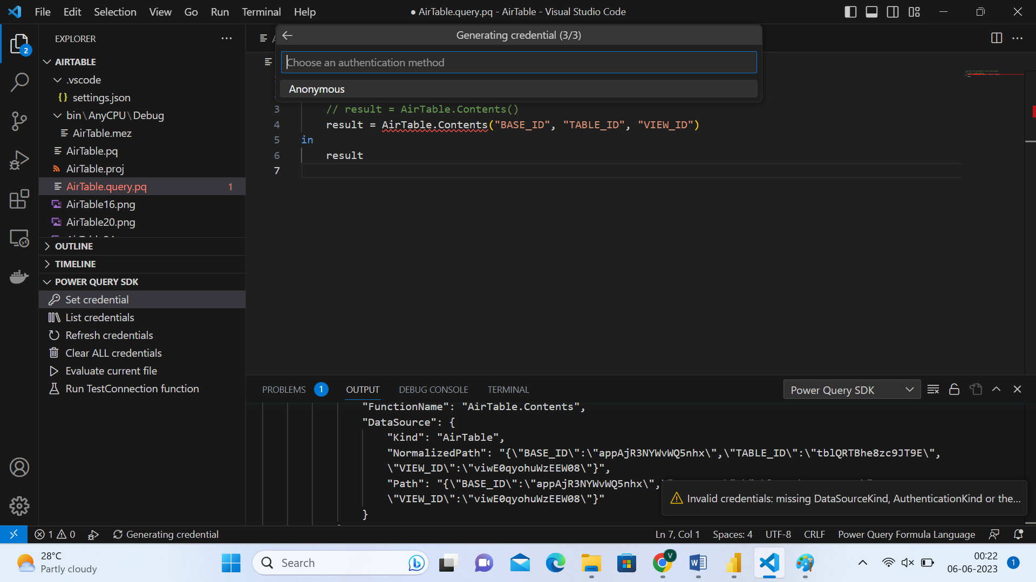

**EVALUATE CURRENT POWER QUERY FILE …(AGAIN)**

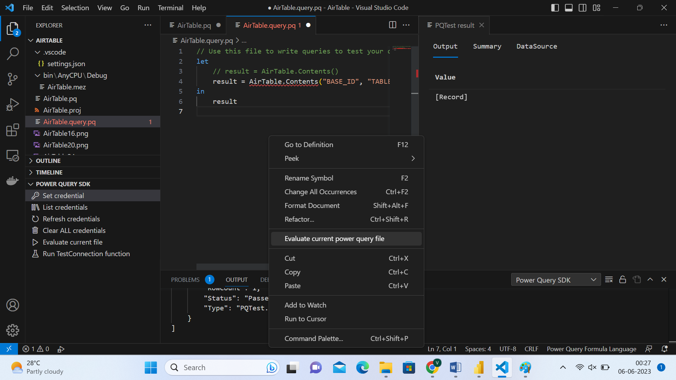

After verifying the result is received by the code,

**Run -> Start Debugging**

the .mez file is copied   
from /bin/AnyCPU/Debug (circled in above image)  
to \Documents\Power BI Desktop\Custom Connectors (custom connector location)

**Installing Custom connector in POWER BI DESKTOP**

**After copying the custom connector as in the last step in previous page**

**Reference:** <https://support.biconnector.com/support/solutions/articles/8000068824-power-bi-warning-about-uncertified-connectors-is-this-an-error->

**Step 1:** Go to **File**menu in Power BI Desktop

**Step 2:** Navigate to **Options and Settings** -> **Options**menu.

**Step 3:** Select **Security**tab.

**Step 4:** Under **Data Extensions** section, by default, "(Recommended) Only allow certified extensions to load" radio button will be selected. Switch it to "(Not Recommeded) Allow any extension to load without validation or warning".

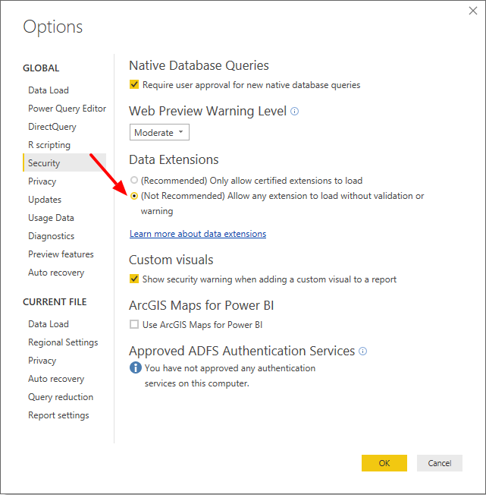

**Step 5:** Now click on the **OK**button and restart Power BI to make the changes effective.

**Step 6:** Close and Open Power BI Desktop (restart)

**Step 7:** Get data -> enter the connector file name in the search box

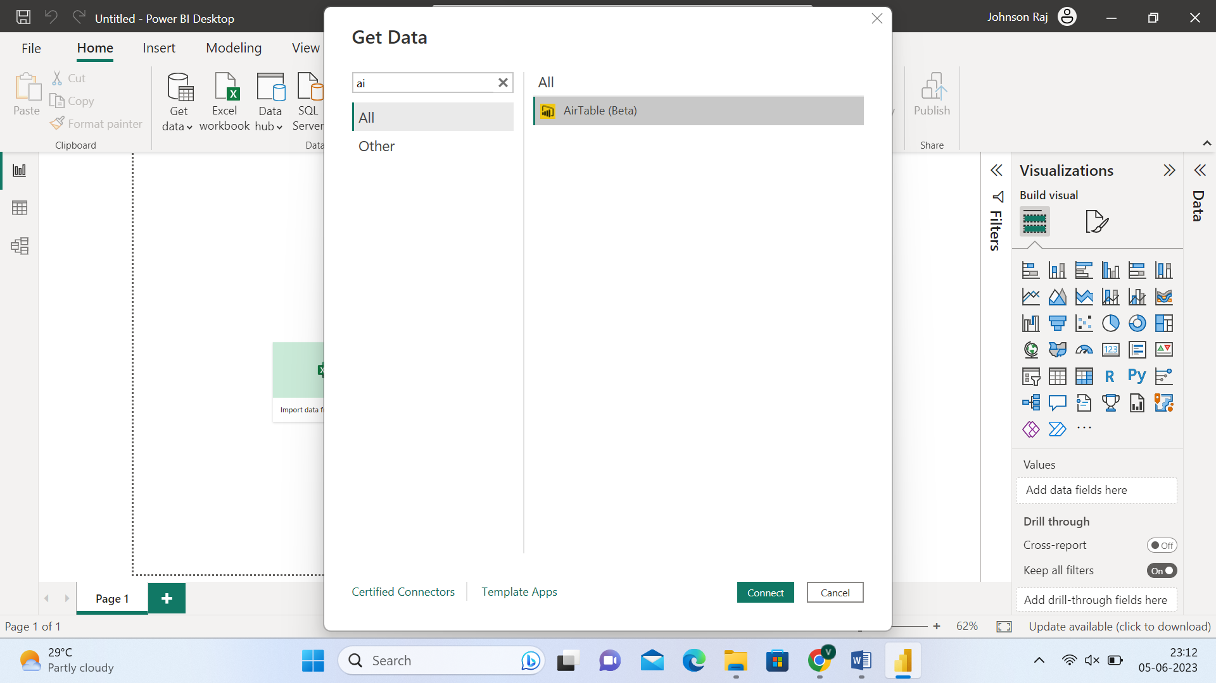

TRANSFORM DATA ->

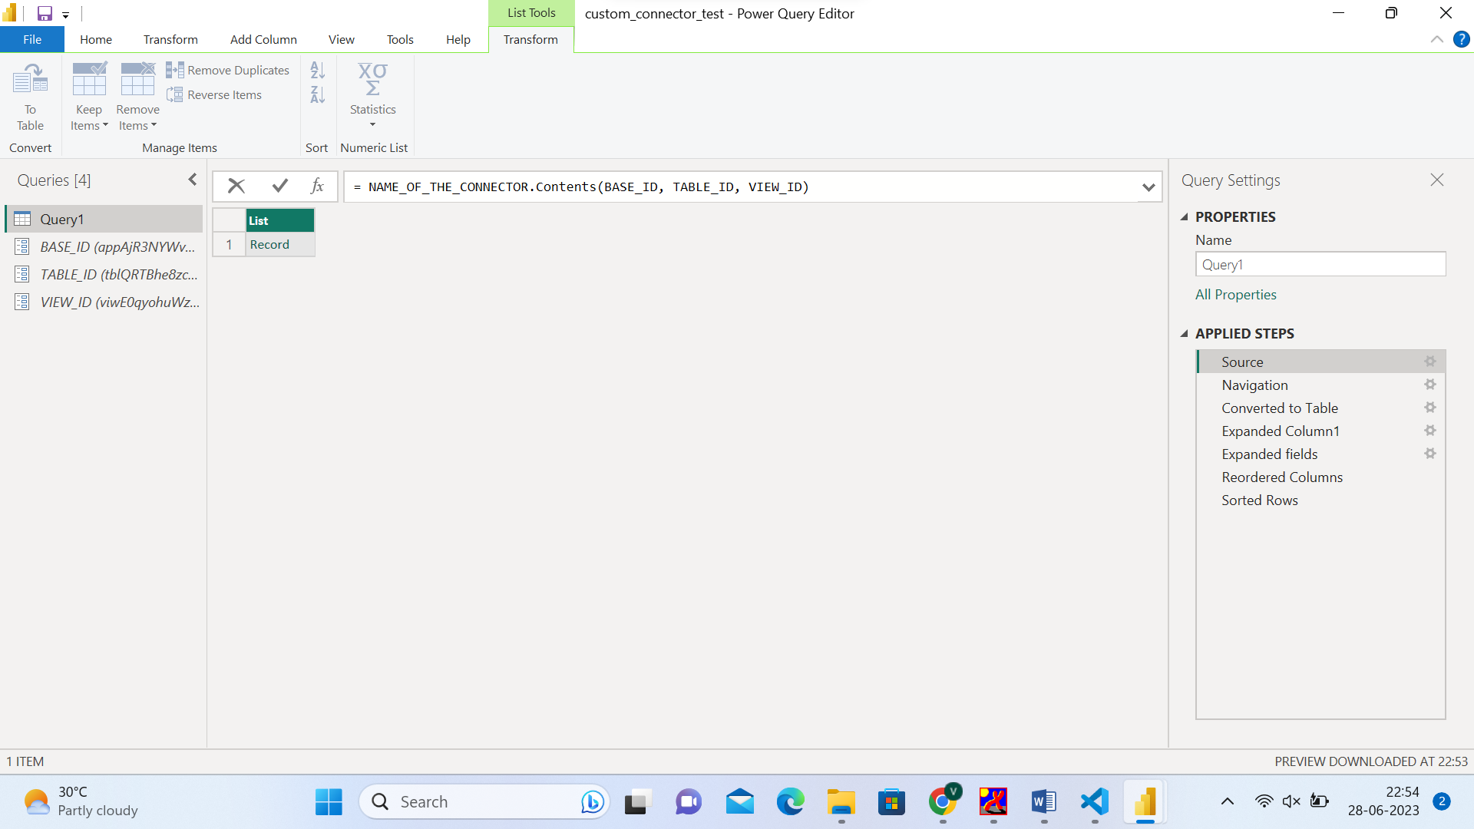

PUBLISH THE REPORT AND DATASET TO PowerBI Service

For the custom connector to work online, we need to setup an **on-premises data gateway (personal mode)**

Refer <https://learn.microsoft.com/en-us/data-integration/gateway/service-gateway-install>

<https://learn.microsoft.com/en-us/power-bi/connect-data/service-gateway-custom-connectors>

DOWNLOAD LINK ->

<https://www.microsoft.com/en-us/download/details.aspx?id=55768>

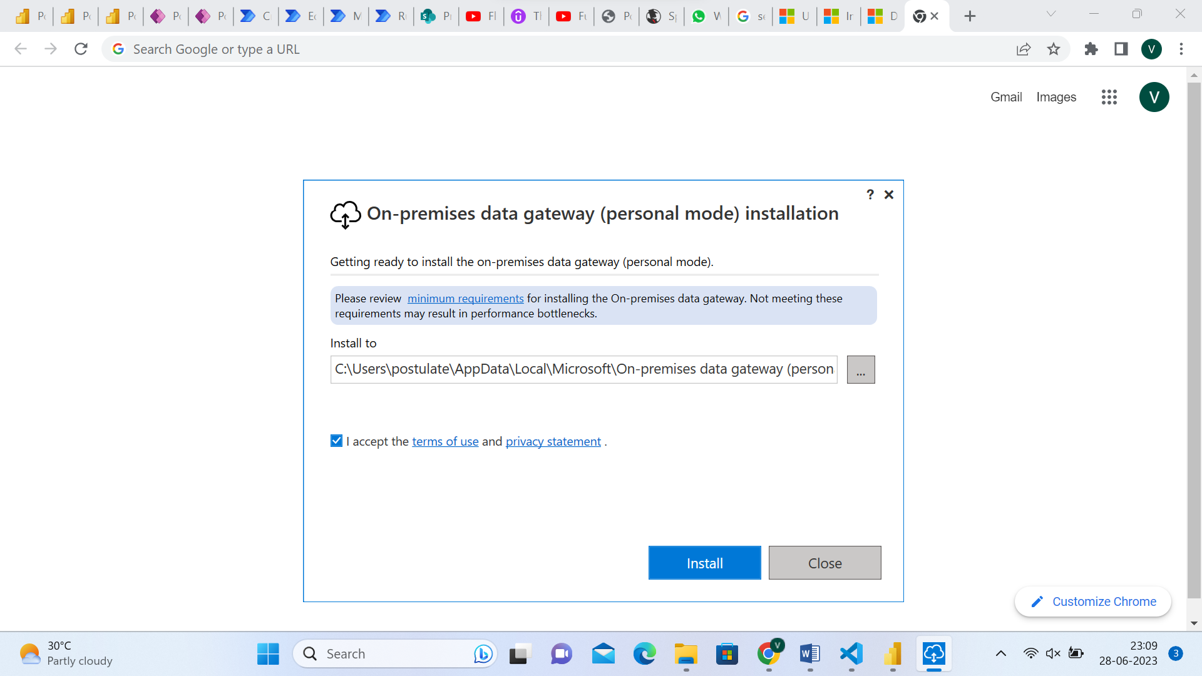

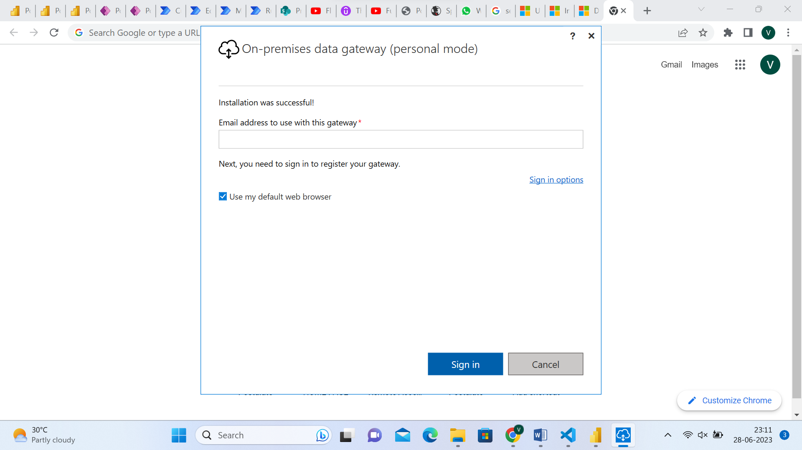

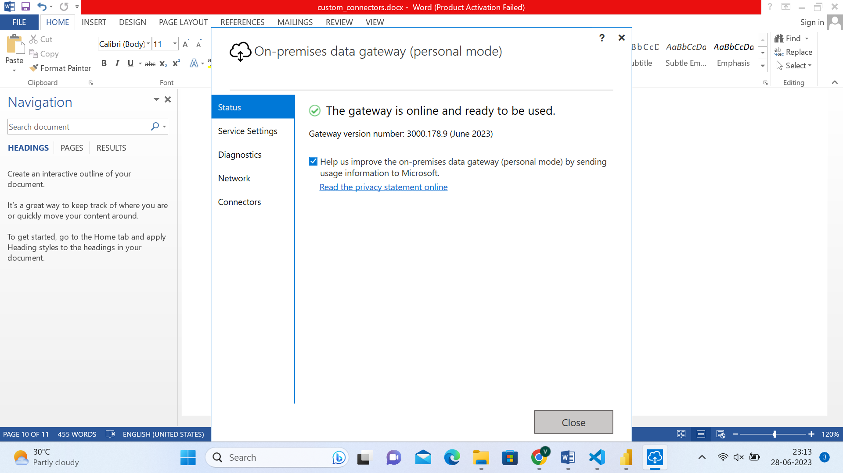

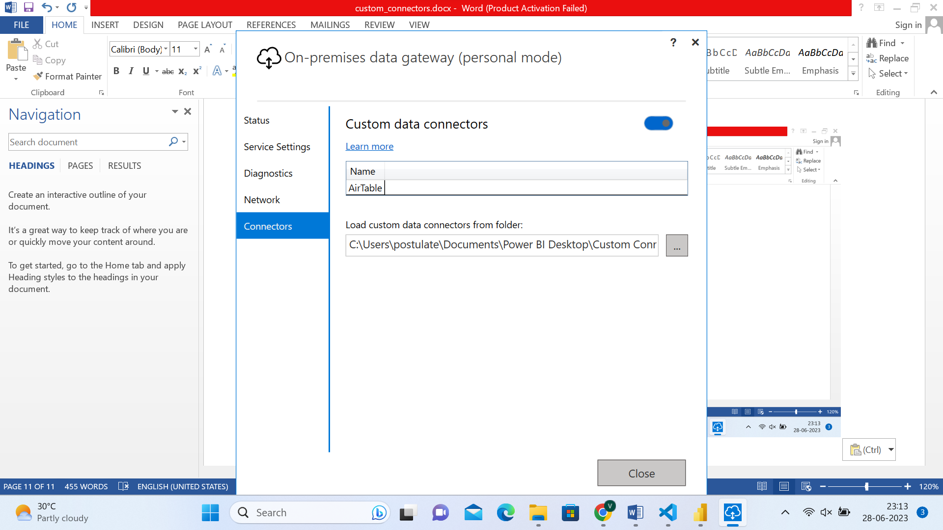

Copy the custom connectors (.mez files) from power BI desktop path to the path in the above window

Keep the online data gateway running in the desktop whenever possible to keep the scheduled refresh in power bi service to run without failure.

1

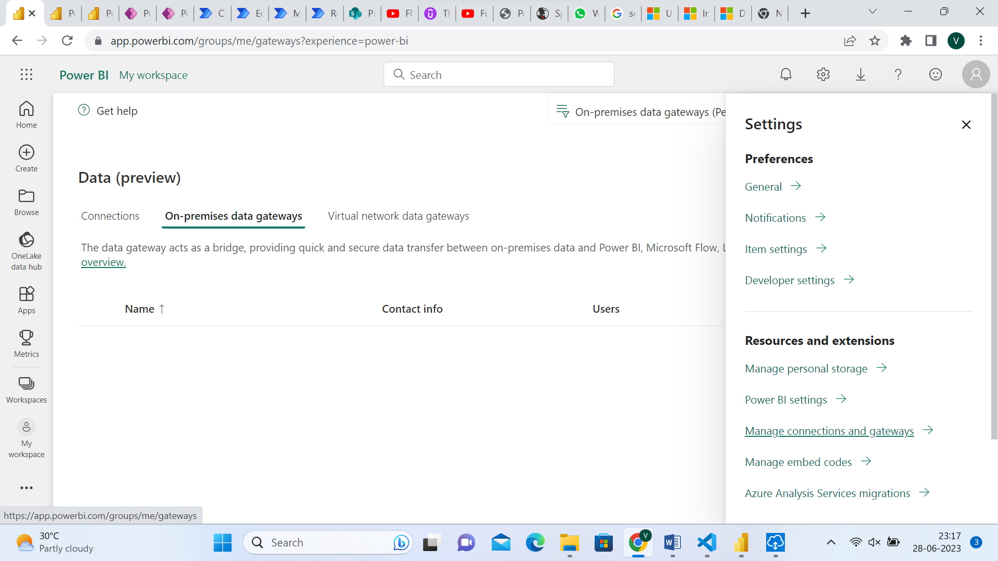

3

2

1